Lab Exercise 4

[Based on Python data types, conditional statements & Loops]

Q1: Write a python program to add all the odd numbers from 0 to 20.

Q 2: Write a python program to find the sum of all integers greater than 100 and less than 200.

Q3: Write a program to display the sum of square of the first ten even natural numbers

Q4|: Write a menu driven program to perform various list operations, such as:
1. Append an element
2. Insert an element at the desired position
3. Append a list to the given list
4. Modify an existing element
5. Delete an existing element by its position
6. Delete an existing element by its value
7. Sort the list in ascending order
8. Sort the list in descending order
9. Display the list
10.Exit

Output:
The list 'myList' has the following elements [22, 4, 16, 38, 13]
L I S T O P E R A T I O N S
1. Append an element
2. Insert an element at the desired position
3. Append a list to the given list
4. Modify an existing element
5. Delete an existing element by its position
6. Delete an existing element by its value
7. Sort the list in ascending order
8. Sort the list in descending order
9. Display the list
10. Exit
ENTER YOUR CHOICE (1-10): 8
The list has been sorted in reverse order
The list 'myList' has the following elements [38, 22, 16, 13, 4]

Q4: Write a python program to display ascii characters from 65 to 90
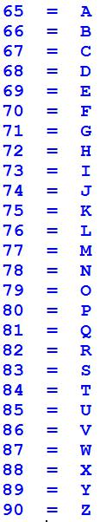

Q5: Display ascii characters from 48 to 57.

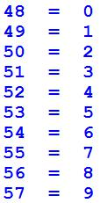

Q6: Display the following output with the help of Ascii character.
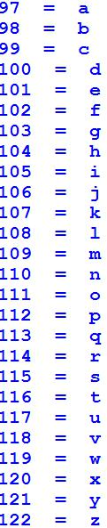

Q7: Write a python program for given a Python list you should be able to display Python list in the following order

L1 = [100, 200, 300, 400, 500]

Expected output:

[500, 400, 300, 200, 100]

Q8: Given a Python list. Write a python program to turn every item of a list into its square List1 = [1, 2, 3, 4, 5, 6, 7]

Expected output:

[1, 4, 9, 16, 25, 36, 49]

Q9: Program to count the number of each vowel in a string.

Q10: write a Program to sort alphabetically the words form a string provided by the user.
[You can use split() method to split string into a list of words. ]

Q 11: write a Program to Remove Punctuations from a String provided by the user. [Hint: use punctuation attribute of string module to get all punctuations (i.e. !"#$%&\'()*+,-./:;<=>?@[\\]^_`{|}~ ) ]

[Nested Loops]

Q12: Write a python program to print the Following:

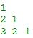

Q13: WAP to print the following asterisk pattern:

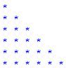

Q14: WAP to create a function traiangle to print the following asterisk triangle pattern:

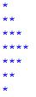

Q15: Write a python program to print following multiplication table on the screen

